ECA-1009 MICROPROCESSOR AND MICROCONTROLLERS

NAME: SAHASRA V
REG NO: 192424234

ARITHMETIC OPERATIONS IN 8085 MICROPROCESSORS

- To write an assembly language program to add two numbers of 8-bit data stored in memory locations 4200H and 4201H and store the result in 4202H and 4203H with carry using direct addressing.

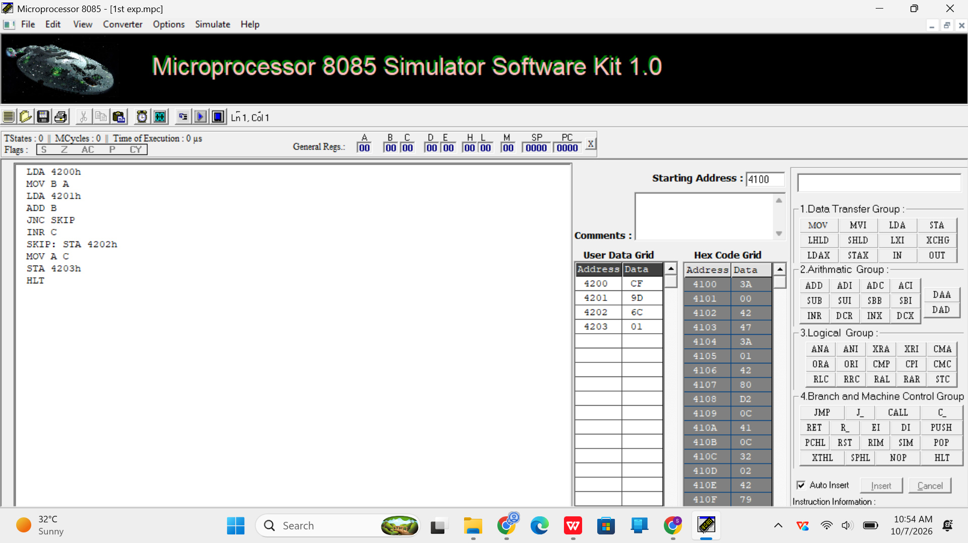

- To write an assembly language program to add two numbers of 8-bit data stored in memory locations 4200H and 4201H and store the result in 4202H and 4203H using indirect addressing modes

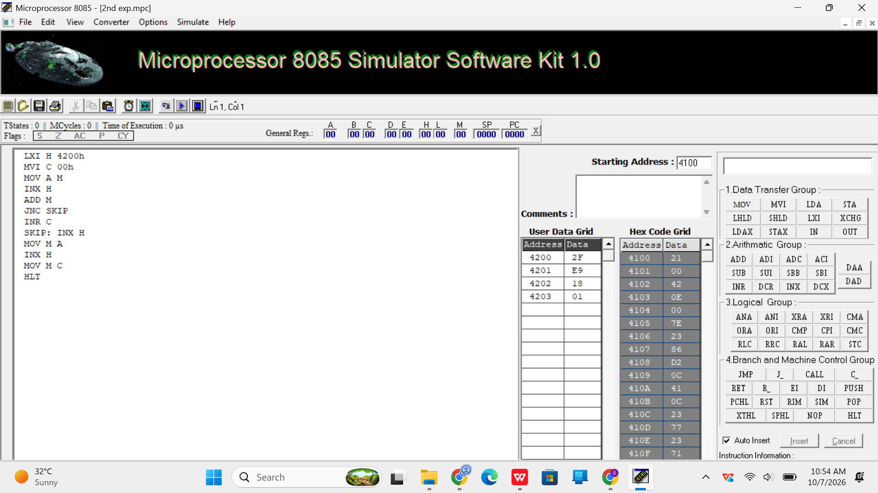

- To write an assembly language program to subtract two numbers of 8-bit data stored in memory 4200H and 4201H. Store the magnitude of the result in 4202H using 8085 Microprocessor.

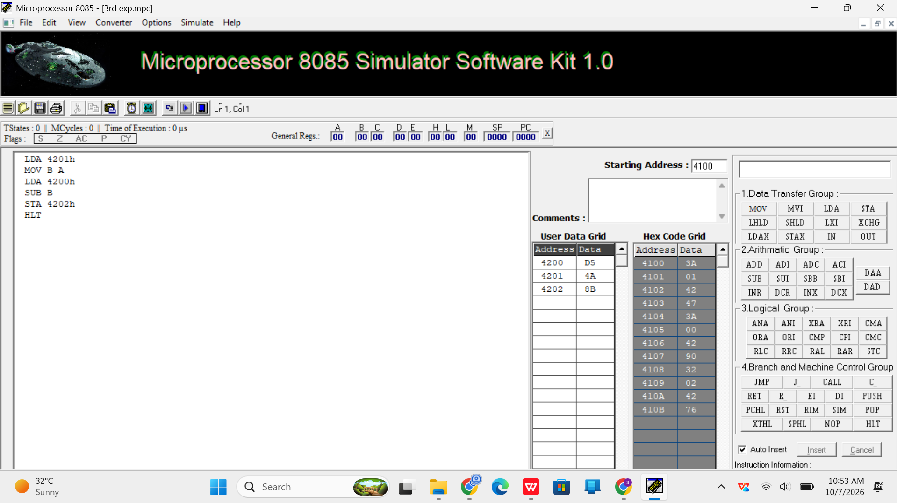

- To write an assembly language program to subtract tow numbers of 8-bit data stored in memory locations 4200H and 4201H and store the result in 4202H and 4203H with borrow using direct addressing.
